1. **Agenda:**
   1. How to run selective features.
2. **Requirement**:
   1. Suppose your project has a lot of feature files and so thousands of scenarios.
   2. But you want to run only those scenarios/Test Cases part of **Regression**.
   3. Some test cases should be run on daily basis, some are related to **Smoke**.  
      So, this way, want to categorize test cases so that result can be achieved fast instead of running all the test cases.
3. Let’s see how to control and execute a particular set of test cases / scenarios.
4. Steps:
   1. **Step 01**:
      1. 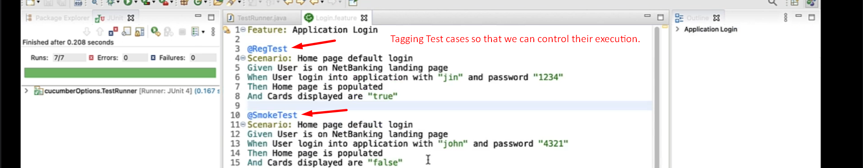
   2. **Step 02**:
      1. Graphical user interface, text

         Description automatically generated  
           
         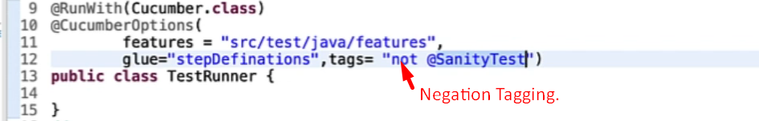
5. Other tags:
   1. 
6. 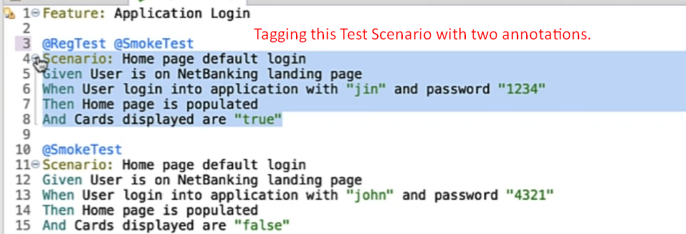
7. Text

   Description automatically generated